Guidelines for Mini-Project Documentation

As per the revised guidelines from the university, the following guidelines are to be followed in preparing the Final Report of the Mini-Project :
Format of Mini Project:
The project shall contain the following sections:
Section-I: It’s a formal general section and shall have the following details.
- Every report should be Hard Cover Page bound (two copies in all)-one for the student and the other for submission to the department.
- The cover page of the Hard Cover bound (First Inner cover page) must contain details of the students:
- Logo of Mangalore University.
- Name of the College
- Department name
- Title of the Mini Project (Font in Times New Roman, Font-size: 16, Bold and Center)
- Submitted By: Name of the Student (Provide name in Capital and Font-size: 14 Times New Roman Font ,Bold and Center)
- UUCMS Register Number(Font size:12 Times New Roman Font)
- Submitted To – Guide Name (Font size:12 Times New Roman)
- Designation and Department name(12 size Times New Roman Font)
- Entire report will be presented in Font size:12 and Times New Roman Font.
- The chapter heading must be centered with letters in font size 14 with Bold, Times New Roman font style. Sections and sub-sections along with their heading must be left justified in font size 12 and apply Bold. The body of the text of the project should have a font size of 12, with a Times New Roman font style.
- Text should be printed on one side of the paper, preferably with 1.5 line spacing, Margin should be 1.5” on the left and 1” on the right. Top 1” and Bottom 1”. Use Times New Roman Font size: 12.

- Report will be prepared on the following lines:
- Certificate of Completion from the organization
- Declaration of the Student
- Acknowledgements – Here, the candidate may thank all those who helped in the preparation of project work
- Index page of content page

Section II: It is a formal technical section that shall consist of the following chapters
  - Synopsis
  - Module Description
  - User Interface – (form / Screen Shots)
  - Source Code
  - Conclusion

Section III: This section shall consist of all such additional information that is not disclosed in the body of the report.
Bibliography

Note :
- It is an individual or group project carried out by a student.
- The report must contain a minimum of 25 pages ( including all pages)
- Maintain 2 hardcopies, 1 for the Department and 1 for the student.
- A soft copy of the Mini-Project report should be maintained in the respective departments (Mail to computerscience@sdmcujire.in).
- Bookbinding is to be done by individual students.
- The guide must maintain the attendance book.




SRI DHARMASTHALA MANJUNATHESHWARA

COLLEGE (AUTONOMOUS), UJIRE-574240

Computer Science Department

Programme Name: BCA

A PROJECT REPORT ON
“Financial Expense Tracker”

SUBMITTED BY :
M.S SHRUTHI
U05SY22S0203
SHREYA J.S
U05SY22S0103

SUBMITTED TO :
MRS. AKSHATHA JAIN
Assistant Professor,
Department of Computer Science

Submitted on : 01/04/2025

SRI DHARMASTHALA MANJUNATHESHWARA COLLEGE (AUTONOMOUS), Ujire - 574240

DEPARTMENT OF COMPUTER SCIENCE
Mini Project Report

Certificate

This is to certify that M.S SHRUTHI and SHREYA J.S bearing the 220918 and 220934 of 3rd BCA has satisfactorily completed the mini-project “Financial Expense Tracker” in the Department of Computer Science, prescribed by the college during the academic year 2024-25.

Mr Shailesh Kumar Mrs. Akshatha Jain
Head of the Department Project Guide

Examiners:

1.

2.

DECLARATION

We hereby declare that this Mini-Project work entitled “Financial Expense Tracker” has been prepared by us during the academic year 2024 - 2025 under the guidance of Mrs. Akshatha Jain, assistant professor, Department of Computer Science, SDM College(Autonomous), Ujire as the partial fulfillment of BCA degree prescribed by the college.

We also declare that this mini-project is the outcome of our efforts and has not been submitted to any other establishments.

Signature
M.S Shruthi,
220918.

Signature
Shreya J.S,
220934.

ACKNOWLEDGEMENT

We would like to thank our principal, Prof. Vishwanatha P, for his support. We also thank Prof. Shailesh Kumar, HOD, Department of Computer Science, SDM College (Autonomous), Ujire, for his valuable suggestions to do the mini project work.

We would like to thank Mrs. Akshatha Jain, assistant professor, Department of Computer Science, SDM College (Autonomous), Ujire, for her help and for guiding in developing this mini-project.

Signature
M.S Shruthi,
220918.

Signature
Shreya J.S,
220934.

INDEX

SL NO | Contents | Page No
1 | Synopsis
2 | Module Description
3 | User Interfaces
4 | Source code
5 | Conclusion
6 | Bibliography

SYNOPSIS
Project Name: Financial Expense Tracker
Overview:
The Financial Expense Tracker is a web-based application designed to help users track and manage their personal finances efficiently. It allows users to sign up and log in securely, storing credentials in the browser's localStorage. Once logged in, users can add transactions, categorizing them as income or expense, along with specifying the amount and description. The app offers several features to manage and view transactions, including filtering by category (income/expense), and searching by transaction description or amount. Users can also delete transactions if needed. All transaction data is stored in localStorage, ensuring that it persists across sessions. The application leverages React for building the user interface, React Router for seamless page navigation (such as between sign-in, sign-up, and transaction management pages), and CSS for styling the layout. The app's features include responsive table displays of transaction records, error handling, and easy navigation, providing a simple yet effective tool for tracking daily expenses and managing personal finances. Overall, the app aims to offer a user-friendly experience for individuals looking to monitor their financial activities with minimal complexity.
Objective:
The goal of the Financial Expense Tracker is to provide an easy-to-use tool for users to manage their finances by tracking income and expenses. Key features include secure sign-up/login, transaction categorization, and the ability to add, view, filter, and search transactions. With data stored in localStorage, the app ensures persistence across sessions. Ultimately, it empowers users to make informed financial decisions, budget effectively, and gain insights into their spending, all through a simple, intuitive interface.
Technologies Used:
Frontend:
- React: For building the user interface and managing state.
- React Router: For navigation between different pages.
- CSS: For styling and responsive design.
- JavaScript: For application logic and functionality.
Backend:
- localStorage: For storing user credentials and transaction data in the browser, ensuring data persistence. (No traditional backend server used).

Module Description

1. User Authentication Module (Sign-Up and Login)
- Purpose: To enable user registration and login functionality, ensuring only authorized access to the expense tracker.
- Functionality:
  - Sign-Up: Users can create a new account by providing a username and password. The app checks if the username is unique and if the passwords match.
  - Login: Registered users can log in using their username and password. Upon successful login, they are redirected to the main dashboard.
  - Displays error messages if credentials are incorrect or if passwords don't match during sign-up.
- Frontend: This module uses React for dynamic user interaction, and CSS for form styling. localStorage is used to persist user data.

2. Transaction Management Module
- Purpose: To allow users to add, view, and delete transactions (income or expenses).
- Functionality:
  - Add Transaction: Users can add income or expense records by specifying the category, amount, and description.
  - View Transactions: Users can view their transaction records in a tabular format.
  - Delete Transactions: Users can delete any unwanted transactions, and these changes are reflected both in the UI and saved in localStorage.
- Frontend: Built using React for state management and UI updates, with CSS for styling the table and form components.

3. Transaction Filter and Search Module
- Purpose: To allow users to filter and search their transaction records for specific categories, amounts, or descriptions.
- Functionality:
  - Filters: Users can filter transactions by category (income or expense).
  - Search: Users can search transactions based on description or amount. The results update dynamically as the user types in the search box.
- Frontend: Managed using React for handling dynamic state updates based on filter and search input, with CSS used to style the input fields and table.

4. Navigation Module
- Purpose: To handle the routing of the application between different pages.
- Functionality:
  - Uses React Router for defining routes and enabling smooth navigation between pages like sign-up, login, and transaction management.
  - Handles redirection upon login and sign-up.
- Frontend: The routing logic is implemented using React Router to manage navigation between pages without reloading the browser.

5. Data Persistence Module
- Purpose: To ensure that user data (login credentials and transactions) are preserved across sessions, even after closing or refreshing the browser.
- Functionality:
  - localStorage is used to store and retrieve user credentials and transaction records.
  - Ensures that when the app is reopened, user data is still available without requiring re-login or data loss.
- Frontend: JavaScript (with React) is used to interact with localStorage for storing user credentials and transactions.

6. 404 Error Page Module
- Purpose: To display a user-friendly error message when the user navigates to a non-existent route.
- Functionality:
  - Catches all unmatched routes and displays a 404 error page, guiding users back to the main page or other valid sections of the app.
- Frontend: This is implemented as a simple React component (PageNotFound.js) that displays a "Page Not Found" message.

USER INTERFACES

1.Landing Page (SignInPage.jsx)
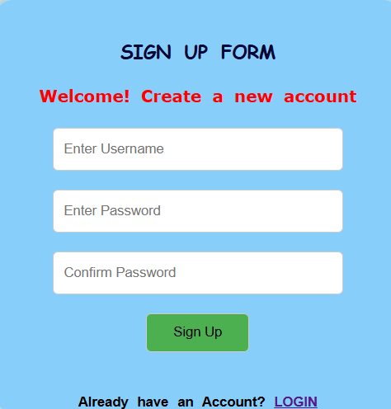

2.LogIn Page (login.jsx)
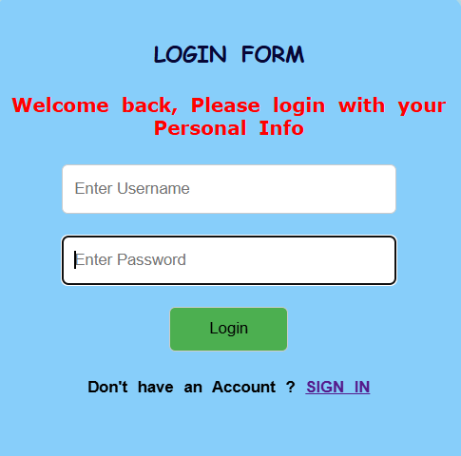

3.Main Page (MainPage.jsx)
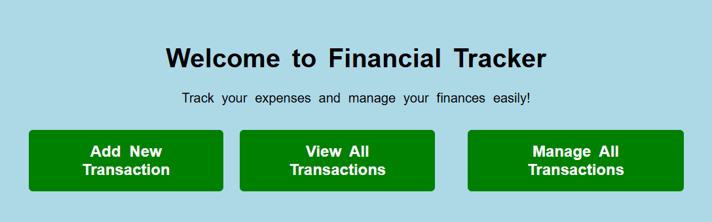
4.Transaction Page (TransactionPage.jsx)
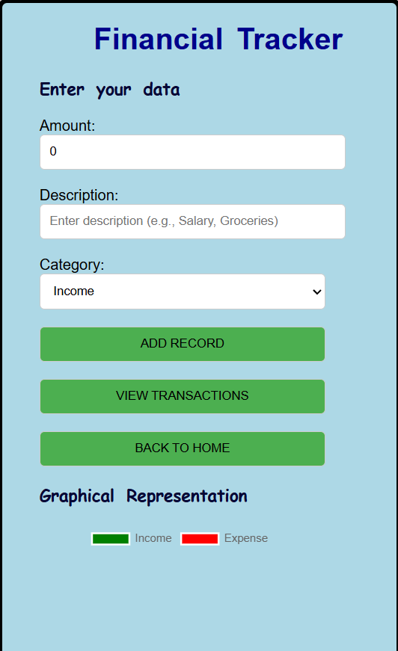

5.View Transaction (ViewTransaction.jsx)

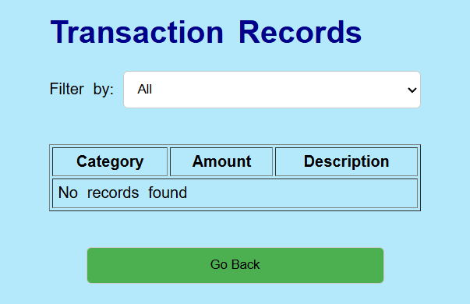

6.Manage Transaction (ManageTransaction.jsx)

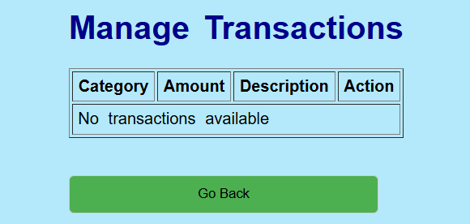

7.Error Page (PageNotFound.jsx)
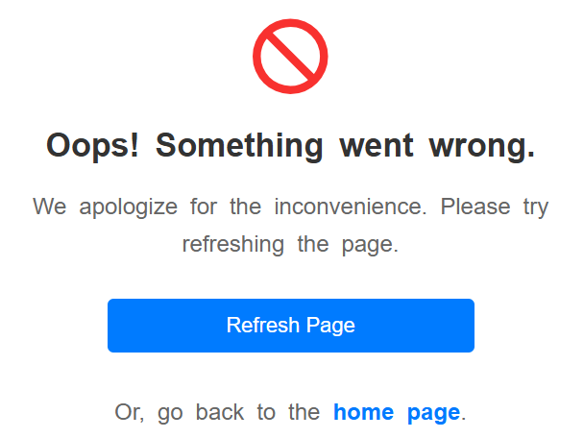

SOURCE CODE
1.Landing Page (SignInPage.jsx)
import React, { useState } from 'react';
import { Link, useNavigate } from 'react-router-dom';

export default function SignIn() {
const [username, setUsername] = useState('');
const [password, setPassword] = useState('');
const [confirmPassword, setConfirmPassword] = useState(''); // New state for confirm password
const navigate = useNavigate();

const handleSignUp = () => {
// Check if passwords match
if (password !== confirmPassword) {
alert('Passwords do not match!');
return;
}

let users = JSON.parse(localStorage.getItem('users')) || [];

// Check if username already exists
if (users.some((user) => user.username === username)) {
alert('Username already exists!');
return;
}

// Add the new user to the array
users.push({ username, password });
localStorage.setItem('users', JSON.stringify(users));
navigate('/Login'); // Redirect to the login page after sign-up
};

return (
<div className="App">
<center>
<form className="loginform" onSubmit={(e) => e.preventDefault()}>
<br />
<h3>SIGN UP FORM</h3>
<h4>Welcome! Create a new account</h4>

<input
type="text"
placeholder="Enter Username"
value={username}
onChange={(e) => setUsername(e.target.value)}
id="textbox"
aria-label="Username"
/>
<br /><br />
<input
type="password"
placeholder="Enter Password"
value={password}
onChange={(e) => setPassword(e.target.value)}
id="textbox"
aria-label="Password"
/>
<br /><br />
<input
type="password"
placeholder="Confirm Password"
value={confirmPassword}
onChange={(e) => setConfirmPassword(e.target.value)}
id="textbox"
aria-label="Confirm Password"
/>
<br /><br />
<button type="button" onClick={handleSignUp} id="signinButton">Sign Up</button><br /><br />
{/* Link to Login page */}
<h5>
Already have an Account? <Link to="/Login">LOGIN</Link>
</h5>
</form>
</center>
</div>
);
}

2.LogIn Page (login.jsx)

import "./App.css";
import React, { useState } from 'react';
import { Link, useNavigate } from 'react-router-dom';

export default function Login() {
const navigate = useNavigate(); // navigate for redirection

const [username, setUsername] = useState('');
const [password, setPassword] = useState('');
const [errorMessage, setErrorMessage] = useState('');

const handleSubmit = (e) => {
e.preventDefault();

setErrorMessage(''); // Reset error message before validation

// Validate input fields (check if username or password is empty)
if (!username || !password) {
setErrorMessage('Please enter both username and password.');
return;
}

// Get stored users from localStorage
const storedUsers = JSON.parse(localStorage.getItem('users')) || [];

// Debugging: log the stored users and entered values
console.log("Stored Users:", storedUsers);
console.log("Entered Username:", username);
console.log("Entered Password:", password);

// Check if entered data matches any stored credentials
const user = storedUsers.find(
(user) => user.username === username && user.password === password
);

if (user) {
setErrorMessage(''); // Clear error message
navigate('/MainPage'); // If successful, navigate to the main page
} else {
setErrorMessage('Invalid credentials. Please try again.');
}
};

return (
<div className="App">
<center>
<form className="loginform" onSubmit={handleSubmit}>
<br />
<h3>LOGIN FORM</h3>
<h4>Welcome back, Please login with your Personal Info</h4>

<input
type="text"
placeholder="Enter Username"
value={username}
onChange={(e) => setUsername(e.target.value)}
id="textbox"
aria-label="Username"
/>
<br /><br />
<input
type="password"
placeholder="Enter Password"
value={password}
onChange={(e) => setPassword(e.target.value)}
id="textbox"
aria-label="Password"
/>
<br /><br />
<button type="submit" id="loginbutton">Login</button>
{/* Link to SignIn page */}
<h5>
Don't have an Account ? <Link to="/">SIGN IN</Link>
</h5>

{/* Display error message if any */}
{errorMessage && <p style={{ color: 'red' }}>{errorMessage}</p>}
</form>
</center>
</div>
);
}

3.Main Page(MainPage.jsx)

import "./App.css";
import React from 'react';
import { Link } from 'react-router-dom';

function MainPage()
{
return (
<div style={containerStyle}>
<h1>Welcome to Financial Tracker</h1>
<p>Track your expenses and manage your finances easily!</p>
<div style={buttonContainerStyle}>
<Link to="/TransactionPage" style={buttonStyle}>
Add New Transaction</Link>
<Link to="/Viewtransaction" style={buttonStyle}>
View All Transactions
</Link>
<br></br>
<Link to="/Managetransaction" style={buttonStyle}>
Manage All Transactions
</Link>
</div>
</div>
);
}

// Styles
const containerStyle = {
maxWidth: '800px',
margin: '0px',
padding: '40px',
backgroundColor: 'lightblue',
borderRadius: '8px',
boxShadow: '0 8px 12px rgba(54, 49, 49, 0.1)',
textAlign: 'center',
};

const buttonContainerStyle = {
marginTop: '30px',
display: 'flex',
justifyContent: 'center',
gap: '20px',
};

const buttonStyle = {
textDecoration: 'none',//underline else
backgroundColor: 'green',
color: 'white',
padding: '15px 30px',
borderRadius: '5px',
fontSize: '1.2rem',
fontWeight: 'bold',
cursor: 'pointer',
};

export default MainPage;

4.Transaction Page(TransactionPage.jsx)

import React, { useState } from "react";
import "./App.css";
import { Pie } from "react-chartjs-2";
import { useNavigate } from "react-router-dom";
import { Chart as ChartJS, ArcElement, Tooltip, Legend, Title, CategoryScale, LinearScale } from "chart.js";

// Register necessary Chart.js components
ChartJS.register(
ArcElement,
Tooltip,
Legend,
Title,
CategoryScale,
LinearScale
);

const TransactionPage = () => {
const [amount, setAmount] = useState(0);
const [description, setDescription] = useState(""); // Description input
const [category, setCategory] = useState("income"); // 'income' or 'expense'
const [records, setRecords] = useState(() => {
// Load records from localStorage or start with an empty array
const storedRecords = JSON.parse(localStorage.getItem("transactionRecords"));
return storedRecords || [];
});
const navigate = useNavigate(); // Navigation hook

const handleAmountChange = (e) => {
setAmount(e.target.value);
};

const handleDescriptionChange = (e) => {
setDescription(e.target.value);
};

const handleCategoryChange = (e) => {
setCategory(e.target.value);
};

const handleAddRecord = () => {
if (amount > 0 && description.trim() !== "") {
const newRecord = { category, amount: parseFloat(amount), description };
const updatedRecords = [...records, newRecord];
setRecords(updatedRecords);
localStorage.setItem("transactionRecords", JSON.stringify(updatedRecords)); // Save to localStorage
setAmount(0);
setDescription(""); // Reset description field after adding
} else {
alert("Please enter a valid amount and description.");
}
};

// Calculate totals for income and expenses
const totalIncome = records.filter(record => record.category === "income").reduce((acc, record) => acc + record.amount, 0);
const totalExpense = records.filter(record => record.category === "expense").reduce((acc, record) => acc + record.amount, 0);

// Pie chart data
const chartData = {
labels: ["Income", "Expense"],
datasets: [
{
data: [totalIncome, totalExpense],
backgroundColor: ["green", "red"],
hoverOffset: 4,
},
],
};

// Pie chart options with reduced size
const chartOptions = {
responsive: true,
maintainAspectRatio: false,
plugins: {
tooltip: {
enabled: true,
},
},
aspectRatio: 1, // Ensures the chart is a square
};

const handleViewTransactions = () => {
navigate("/Viewtransaction"); // Navigate to Viewtransaction page
};

return (
<div className="border">
<div className="transactionbody">
<div >
<center><h1>Financial Tracker</h1></center>

<h3>Enter your data</h3>
<label>Amount: </label><br></br>
<input type="number" value={amount} onChange={handleAmountChange} />
<br/><br/>

<label>Description: </label><br></br>
<input
type="text"
value={description}
onChange={handleDescriptionChange}
placeholder="Enter description (e.g., Salary, Groceries)"
/>
<br/></br/>

<label>Category: </label><br></br>
<select value={category} onChange={handleCategoryChange}>
<option value="income">Income</option>
<option value="expense">Expense</option>
</select>
<br/><br/>

<button onClick={handleAddRecord}>ADD RECORD</button><br></br><br></br>
<button onClick={handleViewTransactions}>VIEW TRANSACTIONS</button>
<br></br><br></br>
button onClick={() => navigate(-1)}>BACK TO HOME</button>// back to previous page
</div>

<div>
<h3>Graphical Representation</h3>
<div style={{ position: 'relative', height: '300px', width: '300px' }}>
<Pie data={chartData} options={chartOptions} />
</div>
</div><br></br>
</div>
</div>
);
};

export default TransactionPage;

5.View Transaction (ViewTransaction.jsx)

import React, { useState, useEffect } from "react";
import { useNavigate } from "react-router-dom";

const Viewtransaction = () => {
const [filter, setFilter] = useState("all");
const [search, setSearch] = useState("");
const [filteredRecords, setFilteredRecords] = useState([]);
const navigate = useNavigate();

// Load records from localStorage
useEffect(() => {
const storedRecords = JSON.parse(localStorage.getItem("transactionRecords")) || [];
setFilteredRecords(storedRecords);
}, []);

// Filter records based on the selected filter and search query
useEffect(() => {
const storedRecords = JSON.parse(localStorage.getItem("transactionRecords")) || [];
const newFilteredRecords = storedRecords.filter((record) => {
if (filter === "all") return true;
if (filter === "income" && record.category === "income") return true;
if (filter === "expense" && record.category === "expense") return true;
if (filter === "description" && record.description.toLowerCase().includes(search.toLowerCase())) return true;
if (filter === "amount" && record.amount.toString().includes(search)) return true;
return false;
});
setFilteredRecords(newFilteredRecords);
}, [filter, search]); // Re-run when filter or search changes

return (
<div className="container">
<div className="content-wrapper">
<h1>Transaction Records</h1>

<div>
<label>Filter by: </label>
<select onChange={(e) => setFilter(e.target.value)} value={filter}>
<option value="all">All</option>
<option value="income">Income</option>
<option value="expense">Expense</option>
<option value="description">Description</option>
<option value="amount">Amount</option>
</select>
</div><br></br>

{filter === "description" || filter === "amount" ? (
<div>
<label>Search: </label>
<input
type="text"
value={search}
onChange={(e) => setSearch(e.target.value)}
placeholder={filter === "description" ? "Enter description to search" : "Enter amount to search"}
/>
</div>
) : null}
<br></br>

{/* Table of filtered records */}
<table border="1" cellPadding={"5"} cellSpacing={"3"} className="viewtable">
<thead>
<tr>
<th>Category</th>
<th>Amount</th>
<th>Description</th>
</tr>
</thead>
<tbody>
{filteredRecords.length === 0 ? (
<tr>
<td colSpan="3">No records found</td>
</tr>
) : (
filteredRecords.map((record, index) => (
<tr key={index}>
<td>{record.category === "income" ? "Income" : "Expense"}</td>
<td>${record.amount}</td>
<td>{record.description}</td>
</tr>
))
)}
</tbody>
</table>
<br></br><br></br>
<center><button onClick={() => navigate(-1)}>Go Back</button>//back to previous page </center>
</div>
</div>
);
};

export default Viewtransaction;

6.Manage Transaction (ManageTransaction.jsx)

import React, { useState, useEffect } from "react";
import { useNavigate } from "react-router-dom";

const Managetransaction = () => {
const [transactions, setTransactions] = useState([]);
const navigate = useNavigate();

// Load transactions from localStorage
useEffect(() => {
const storedTransactions = JSON.parse(localStorage.getItem("transactionRecords")) || [];
setTransactions(storedTransactions);
}, []);

// Function to handle deleting a transaction
const handleDelete = (index) => {
const updatedTransactions = [...transactions];
updatedTransactions.splice(index, 1); // Remove the record at the given index
setTransactions(updatedTransactions); // Update the state

// Update localStorage
localStorage.setItem("transactionRecords", JSON.stringify(updatedTransactions));
};

return (
<div className="container">
<div className="content-wrapper">
<h1>Manage Transactions</h1>

{/* Table of transactions with delete functionality */}
<table className="viewtable" border="1" cellPadding={"5"} cellSpacing={"3"}>
<thead>
<tr>
<th>Category</th>
<th>Amount</th>
<th>Description</th>
<th>Action</th>
</tr>
</thead>
<tbody>
{transactions.length === 0 ? (
<tr>
<td colSpan="4">No transactions available</td>
</tr>
) : (
transactions.map((transaction, index) => (
<tr key={index}>
<td>{transaction.category === "income" ? "Income" : "Expense"}</td>
<td>${transaction.amount}</td>
<td>{transaction.description}</td>
<td>
{/* Show delete button for every transaction */}
<center>
<button className="deletebutton" onClick={() => handleDelete(index)} style={{ backgroundColor: "red", color: "white" }}>Delete</button></center>
</td>
</tr>
))
)}
</tbody>
</table>
<br></br><br></br>
<button onClick={() => navigate(-1)}>Go Back</button> {/* Go back to the Main page */}
</div>
</div>
);
};

export default Managetransaction;

7.Error Page(PageNotFound.jsx)

import React from 'react';
import { Link } from 'react-router-dom'; // Link to redirect users back to the homepage

const PageNotFound = () => {
const handleRefresh = () => {
window.location.reload(); // Refresh the page
};

return (
<div style={styles.content}>
<h1 style={styles.emoji}>🚫</h1> {/* Barrier emoji above the title */}
<h1 style={styles.title}>Oops! Something went wrong.</h1>
<p style={styles.message}>We apologize for the inconvenience. Please try refreshing the page.</p>
<div style={styles.buttons}>
<button style={styles.refreshButton} onClick={handleRefresh}>
Refresh Page
</button>
<p style={styles.message}>
Or, go back to the <Link to="/" style={styles.link}>home page</Link>.
</p>
</div>
</div>
);
};

// Modern, clean styles for the error page
const styles = {
content: {
textAlign: 'center',
backgroundColor: '#fff', // White background for the content box
padding: '40px 30px',
borderRadius: '8px',
boxShadow: '0 4px 10px rgba(0, 0, 0, 0.1)',
maxWidth: '450px',
width: '100%',
},
emoji: {
fontSize: '4rem', // Larger size for the barrier emoji
marginBottom: '20px',
},
title: {
fontSize: '1.7rem', // Slightly larger title for emphasis
color: '#333',
fontWeight: 'bold',
marginBottom: '20px',
},
message: {
fontSize: '1.2rem',
color: '#666',
marginBottom: '20px',
lineHeight: '1.6', // Better spacing between lines for readability
},
buttons: {
marginTop: '30px',
},
refreshButton: {
padding: '12px 30px',
fontSize: '1.1rem', // Slightly larger button text
backgroundColor: '#007BFF', // Blue color for button
color: '#fff',
border: 'none',
borderRadius: '5px',
cursor: 'pointer',
transition: 'background-color 0.3s ease, transform 0.2s ease',
marginBottom: '15px',
},
refreshButtonHover: {
backgroundColor: '#0056b3', // Darker blue for hover
},
link: {
color: '#007BFF',
textDecoration: 'none',
fontWeight: 'bold',
},
};

export default PageNotFound;

8.App.css (css for Pages)

.loginform
{
text-align: center;
margin-top: 2px;
margin-left: 550px;
border: 3px solid lightblue;
background-color:lightskyblue;
height:400px;
width:394px;
border-radius: 20px;
}

#loginbutton,#signinButton
{
width:100px;
}

#textbox
{
width: 260px;
height:20px;
}

h3{
font-size: large;
font-family:cursive;
font-weight: bold;
color:rgb(7, 7, 53);
}

h1{
color:darkblue;
}

h4{
color:red;
font-family: Verdana, Geneva, Tahoma, sans-serif;
}

.signinform
{
text-align: center;
margin-top: 2px;
margin-left: 560px;
border: 3px solid lightblue;
background-color:lightskyblue;
height:380px;
width:400px;
border-radius: 20px;
}

.App {
font-family: 'Arial', sans-serif;
text-align: center;
margin-top: 2px;
margin-right: 500px;
}

input, select ,button{
padding: 10px;
margin: 0px;
border-radius: 5px;
border: 1px solid #ccc;
width: 20vw;
}

.container {
display: flex;
flex-direction: column;
align-items: center;
margin-top: 2px;
background-color: rgb(180, 233, 251);
border-radius: 10px;
width: 500px;
height:500px;
border-color: rgb(53, 193, 193);
}

button{
background-color: #4CAF50;
}

button:hover {
background-color: #45a049;
}
body {
margin: 0;
font-family: Arial, sans-serif;
background-color: #dbd3d3;
display: flex;
justify-content: center;
align-items: center;
height: 160vh;
padding: 20px;
word-spacing:5px;
}
.viewtable
{
width:100%;

}
.border
{
border:5px solid;
border-radius: 10px;
height:120vh;
width:25vw;
padding-left: 40px;
background-color: lightblue;
}
.deletebutton
{
width:60px;
}

9.App.js

import React from 'react';
import { BrowserRouter, Routes, Route } from 'react-router-dom';
import Login from './Pages/Login'; // Import your Login component
import SignInpage from './Pages/SignInpage'; // Import your SignInpage component
import MainPage from './Pages/MainPage'; // Import your Dashboard component (for redirection after login)
import TransactionPage from './Pages/TransactionPage';
import Viewtransaction from './Pages/Viewtransaction';
import Managetransaction from './Pages/Managetransaction';
import PageNotFound from './Pages/PageNotFound';

function App() {
return (
<BrowserRouter>
<Routes>
{/* Define main routes */}
<Route path="/" element={<SignInpage />} /> // Landing page / Sign-in
<Route path="/login" element={<Login />} /> // Main login page
<Route path="/MainPage" element={<MainPage />} /> //After login redirect
<Route path="/TransactionPage" element={<TransactionPage />} /> //Transaction Page
<Route path="/Viewtransaction" element={<Viewtransaction />} /> // View Transaction
<Route path="/Managetransaction" element={<Managetransaction />} /> //Manage Transaction
{/* 404 Page Not Found Route */}
<Route path="*" element={<PageNotFound />} /> //Wildcard for unmatched routes
</Routes>
</BrowserRouter>
);
}

export default App;

Conclusion
In conclusion, the "Financial Expense Tracker" project stands as an effective, scalable, and user-centric solution for managing personal finances. By integrating essential features such as adding, viewing, managing, and categorizing financial transactions, it provides users with a seamless and intuitive platform to track both income and expenses. The use of localStorage ensures that transaction data persists even after page reloads, making the application reliable and persistent. The inclusion of advanced filtering and search options, alongside a powerful pie chart for visualizing income versus expenses, further enhances the user's ability to manage and analyze their financial data effortlessly. The easy-to-understand graphical representation of financial data helps users quickly grasp their spending patterns, empowering them to make smarter financial decisions.
This project showcases the strong synergy between React for dynamic, interactive interfaces, localStorage for efficient client-side data storage, and Chart.js for delivering visually appealing and insightful data visualizations. The pie chart, in particular, provides an instant snapshot of how income and expenses are balanced, allowing users to visualize their financial health with ease. By offering a robust, feature-rich experience that addresses key financial management needs, the app not only empowers users to make informed decisions but also ensures ease of use and responsiveness, making it an indispensable tool for anyone looking to take control of their finances. Through this project, we demonstrate a clear understanding of modern web development principles, user experience best practices, and data visualization techniques, providing a complete and reliable solution for personal financial tracking. Ultimately, this Financial Expense Tracker is designed to help users stay on top of their finances, build better financial habits, and visualize their progress over time.

Bibliography

